EXPT NO:1 | Implementation of data charts
DATE: 06.01.2026 | Implementation of data charts

PRE-LAB QUESTIONS (PROVIDE BRIEF ANSWERS TO THE FOLLOWING QUESTIONS)

1. How can visualization help an academic institution improve student outcomes?
Visualization reveals performance patterns, weak subjects, and trends quickly, enabling faculty to intervene early and improve teaching strategies based on evidence instead of assumptions.
2. Which chart types are suitable for comparing subject-wise performance?
Bar charts and grouped bar charts are most suitable for comparing average marks across subjects.
3. What type of data scale is used for student marks?
Student marks use a ratio scale since they have a true zero and meaningful differences.
4. Why should raw academic data be cleaned before visualization?
Raw data may contain missing values, inconsistencies, or outliers that can distort charts and lead to wrong conclusions.
5. How does visualization support evidence-based decision making?
It converts raw numbers into interpretable insights, allowing decisions to be backed by observable trends and comparisons.
IN-LAB EXERCISE:
OBJECTIVE:
To design appropriate data charts to analyze and compare academic performance indicators.
SCENARIO:
An autonomous engineering college wants to analyze internal assessment performance of first-year students across five subjects to identify difficult courses and improve teaching strategies.
IN-LAB TASKS (Using R Language)
- Load required R libraries (ggplot2, dplyr)
- Import dataset using read.csv()
- Perform basic data preprocessing
- Create bar chart for subject-wise average marks
- Generate line chart for performance trend across tests
- Plot pie chart for grade distribution

CODE :

# Lab Exercise by Student: 23BAD109
library(ggplot2)
library(dplyr)
# Read student performance data
data <- read.csv("1.student_performance.csv")
head(data)
# Calculate average of internal tests
data <- data %>%
mutate(Average_Internal = (Internal_Test1 + Internal_Test2) / 2)
head(data)

# Subject-wise average internal marks
subject_avg <- data %>%
group_by(Subject) %>%
summarise(Avg_Marks = mean(Average_Internal))
subject_avg
# Bar plot: Subject-wise average internal marks
ggplot(subject_avg, aes(x = Subject, y = Avg_Marks, fill = Subject)) +
geom_bar(stat = "identity") +
labs(
title = "Subject-wise Average Internal Marks",
x = "Subject",
y = "Average Marks"
) +
theme_minimal()
# Average marks across internal tests
test_avg <- data %>%
summarise(
Internal_Test1 = mean(Internal_Test1),
Internal_Test2 = mean(Internal_Test2)
)
test_avg_long <- data.frame(
Test = c("Internal Test 1", "Internal Test 2"),
Average = c(test_avg$Internal_Test1, test_avg$Internal_Test2)
)
# Line plot: Performance trend across internal tests
ggplot(test_avg_long, aes(x = Test, y = Average, group = 1)) +
geom_line() +
geom_point(size = 3) +
labs(
title = "Performance Trend Across Internal Tests",
x = "Test",
y = "Average Marks"
) +
theme_minimal()
# Grade distribution
grade_dist <- data %>%
group_by(Final_Grade) %>%
summarise(Count = n())
# Pie chart: Grade distribution
ggplot(grade_dist, aes(x = "", y = Count, fill = Final_Grade)) +
geom_bar(stat = "identity", width = 1) +
coord_polar("y") +
labs(title = "Grade Distribution") +
theme_void()
my_roll_no <- "23BAD109"
print(paste("Lab completed by roll number:", my_roll_no))

OUTPUT :

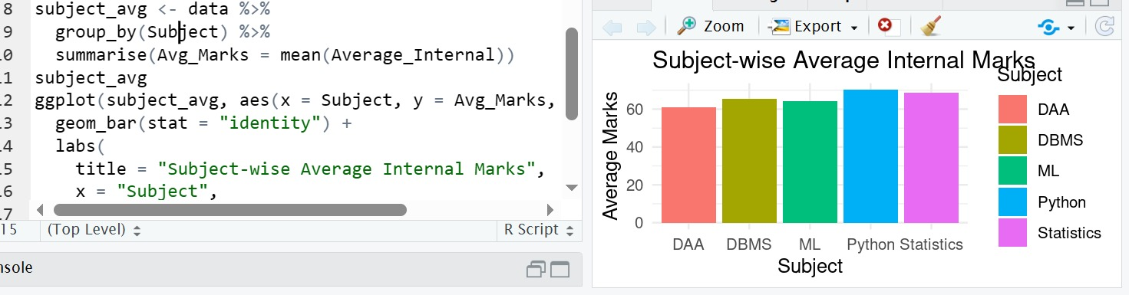

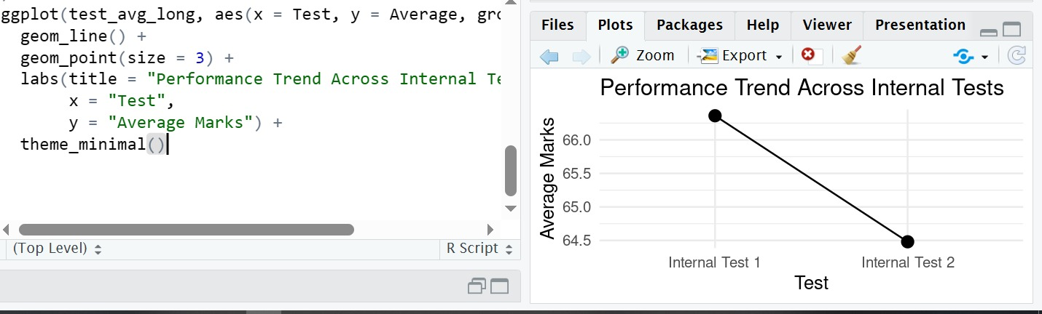

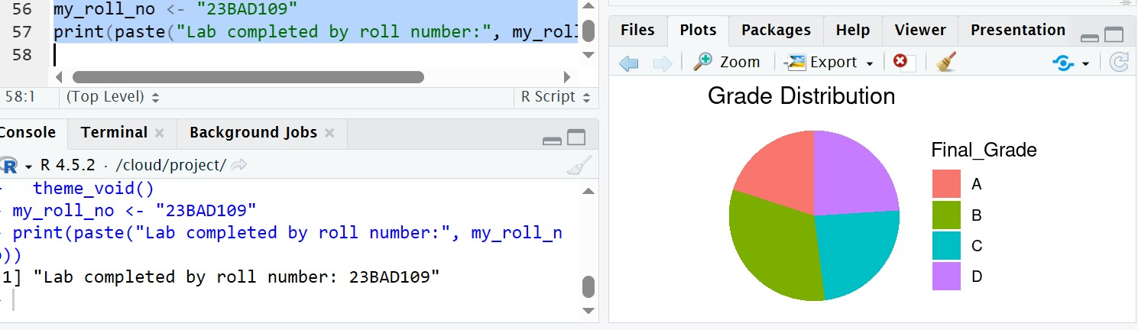

POST-LAB QUESTIONS (PROVIDE BRIEF ANSWERS TO THE FOLLOWING QUESTIONS)
1. Which subject shows consistently low performance and why?
Subjects with lower average internal marks indicate higher difficulty or ineffective teaching strategies, requiring curriculum review or additional academic support.
2. Why is a line chart suitable for trend analysis?
Line charts clearly show changes over time or sequence, making trends easy to interpret.
3. What limitations does a pie chart have in analytics?
Pie charts do not show precise differences well and become ineffective with many categories.
4. How can this analysis help curriculum planning?
It identifies difficult subjects, enabling syllabus redesign, faculty training, and targeted interventions.
5. How can such visualizations be integrated into AI-driven academic analytics?
They can be embedded into AI dashboards to predict student risk, recommend interventions, and personalize learning paths.

ASSESSMENT
Description | Max Marks | Marks Awarded
Pre Lab Exercise | 5
In Lab Exercise | 10
Post Lab Exercise | 5
Viva | 10
Total | 30
Faculty Signature

